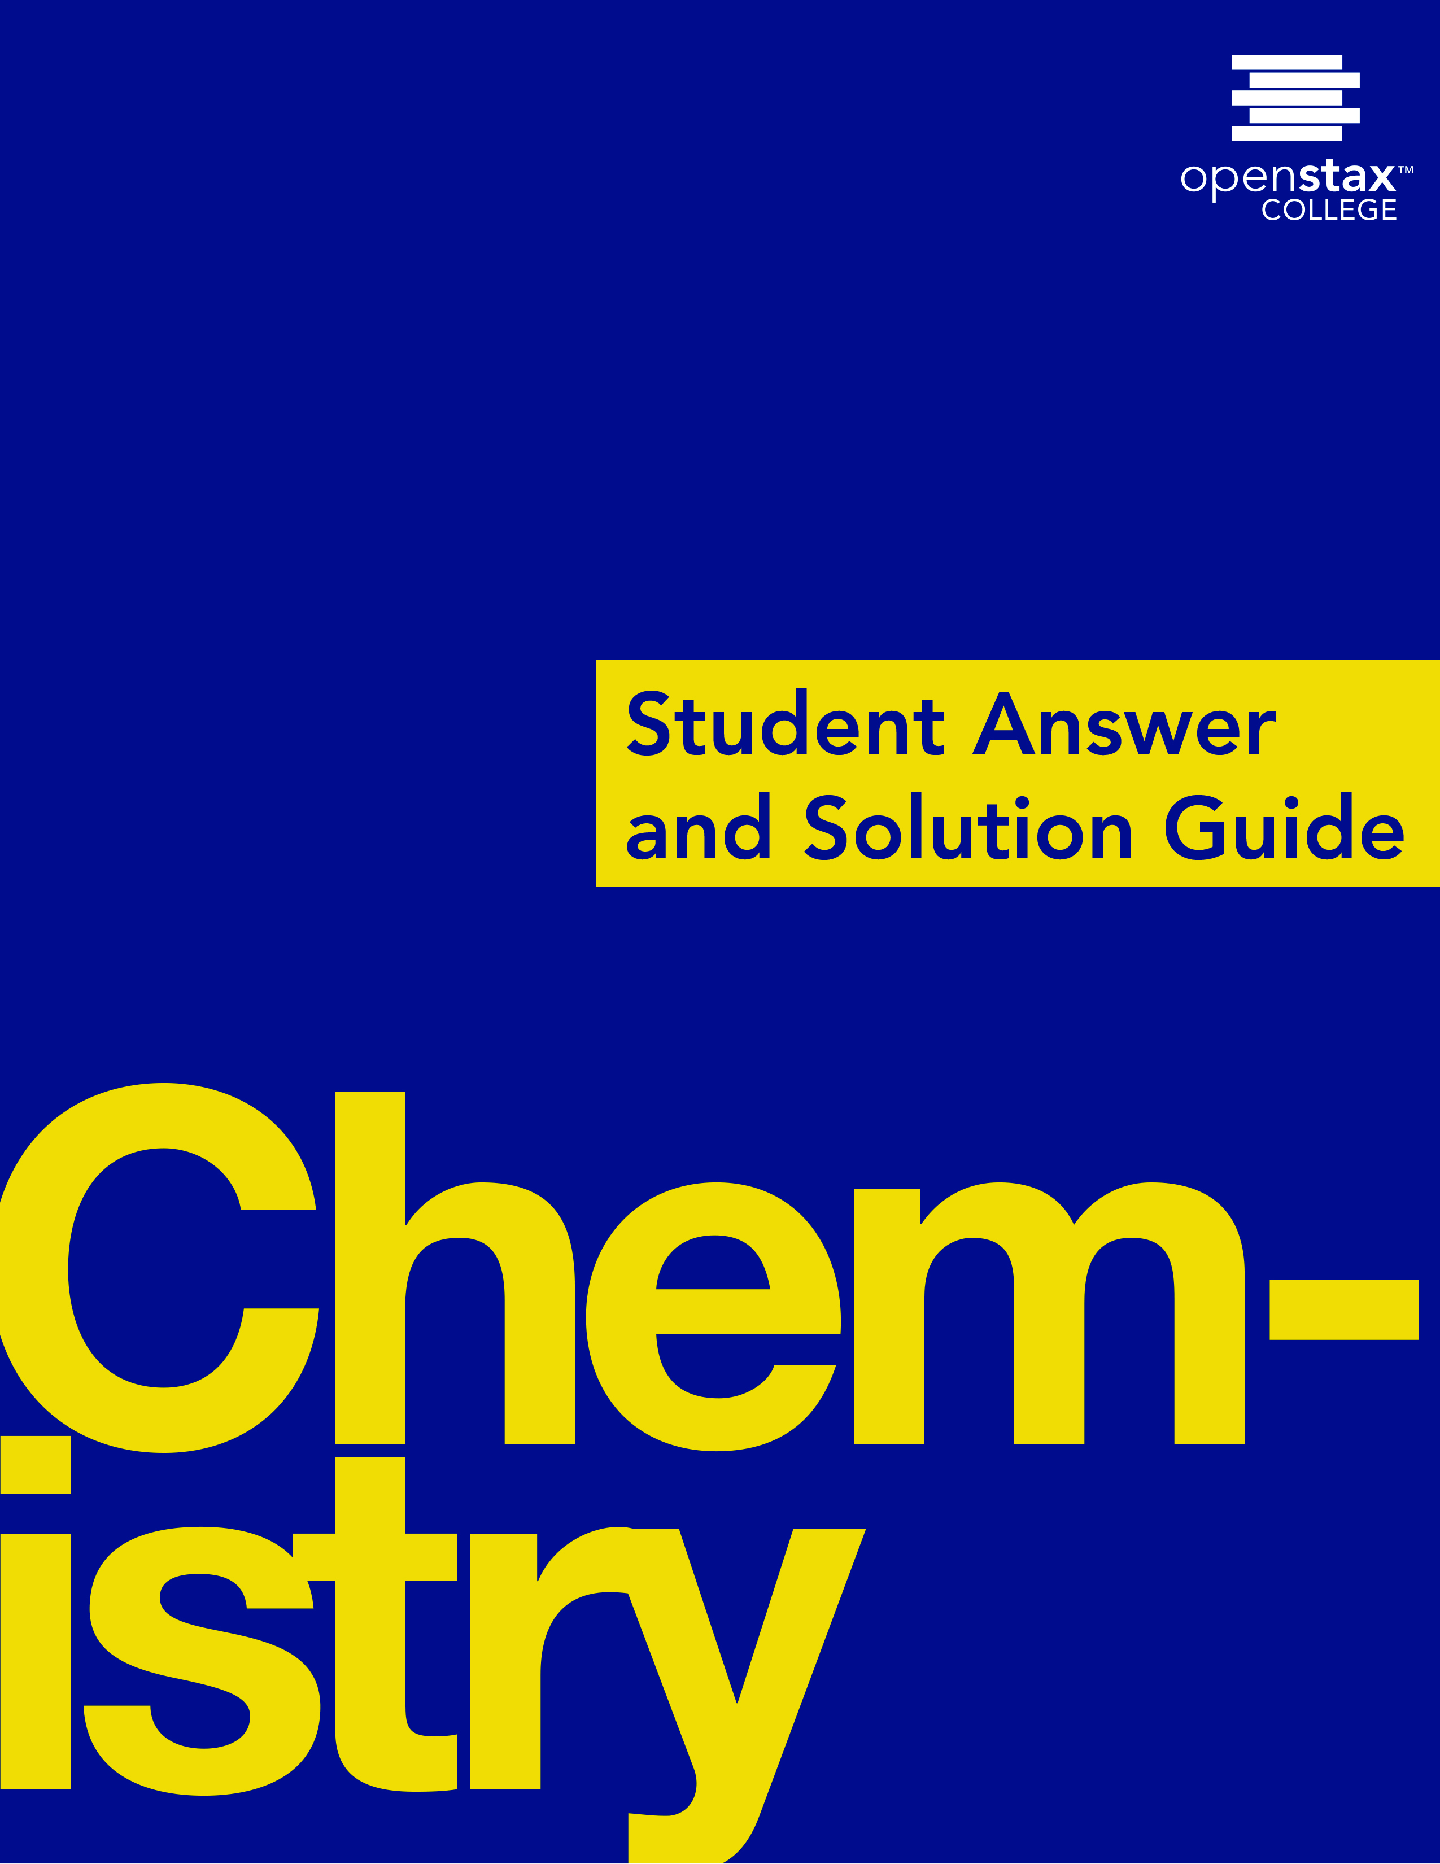

***Chemistry***

**1: Essential Ideas**

**1.1: Chemistry in Context**

1. Explain how you could experimentally determine whether the outside temperature is higher or lower than 0 °C (32 °F) without using a thermometer.

Solution

Place a glass of water outside. It will freeze if the temperature is below 0 °C.

3. Identify each of the following statements as being most similar to a hypothesis, a law, or a theory. Explain your reasoning.

(a) The pressure of a sample of gas is directly proportional to the temperature of the gas.

(b) Matter consists of tiny particles that can combine in specific ratios to form substances with specific properties.

(c) At a higher temperature, solids (such as salt or sugar) will dissolve better in water.

Solution

(a) law (states a consistently observed phenomenon, can be used for prediction); (b) theory (a widely accepted explanation of the behavior of matter); (c) hypothesis (a tentative explanation, can be investigated by experimentation)

5. Identify each of the underlined items as a part of either the macroscopic domain, the microscopic domain, or the symbolic domain of chemistry. For those in the symbolic domain, indicate whether they are symbols for a macroscopic or a microscopic feature.

(a) A certain molecule contains one H atom and one Cl atom.

(b) Copper wire has a density of about 8 g/cm3.

(c) The bottle contains 15 grams of Ni powder.

(d) A sulfur molecule is composed of eight sulfur atoms.

Solution

(a) symbolic, microscopic; (b) macroscopic; (c) symbolic, macroscopic; (d) microscopic

7. The amount of heat required to melt 2 lbs of ice is twice the amount of heat required to melt 1 lb of ice. Is this observation a macroscopic or microscopic description of chemical behavior? Explain your answer.

Solution

Macroscopic. The heat required is determined from macroscopic properties.

This resource file is copyright 2015, Rice University. All Rights Reserved.